Functional requirements
- As an employee, I want to register in the system a new pet given its type (Dog, Cat, Bird, Fish, Rodent, Hamster, Turtle etc.), price, color, age, gender, name, additional comments.
  - If the pet type is “Dog” or “Cat” then also the specific breed and the name of the breeder, if the name is known.
  - If the pet type is “Fish” then also their species, if they are or aren’t predators and if the are salt or freshwater fishes.
  - If the pet type is “Bird” then also their species and optionally their preferred type of food.
  - If the pet type is “Rodent” then also their species and if they are or aren’t biting while feeding.
  - If the pet is of another type, then also their species.
This, so that the new pet could be sold in the shop department.
- As an employee, I want to register a new customer with a name, unique phone number and unique email address so the customer can be contacted by phone or email address.
- As an employee, I want to register a new sale with a pet and the customer’s data, as long as the customer is registered in the system, so the sales information is stored in the system.
- As an employee, I want to make a kennel reservation given the customer information, the reservation period, pet information and the price for the reservation, so that the customer can book a room in the kennel.
- As an employee, I want to view pet details (Name, Age, Color, Price, Gender, Additional comments) by searching through all pet data's with the same type, so a pets information is easily accessed and viewed.
- As an employee, I want to modify a pet data (Name, Age, Color, Price, Gender, Additional comments) as long as the entered price is a positive value (for a non-kennel pet), the gender is either male or female and the age is a positive value. This, in order to have updated pet information.
- As an employee, I want to be able to manually remove a pet data. This, so that the dead pets or the ones purchased a long time ago do not stay registered in the system.
- As an employee, I want to view customer’s data (Name, Phone Number, Email) by searching through all customers datas or by entering a part of a name in the system. This, so the customer’s information can be easily accessed and viewed.
- As an employee, I want to edit a customer data(Name, Phone Number, Email) as long as the new phone number or the new email address does not match another phone number or email in the system. This, in order to have updated customer information.
- As an employee, I want to be able to manually remove a customer, so that inactive customers do not stay registered in the system.
- As an employee, I want to make kennel reservations exclusively for customers registered in the system, so the customer’s information is readily available.
- As an employee, I want to view a kennel reservation details (Pet, Customer, Check-in date and time, Check-out date and time, Finale price) by searching through all kennel reservations or by entering a part of a name, a part of color or breed/species or by entering the full check-in date. This, so the kennel reservations data can be easily accessed and viewed.
- As an employee, I want to be able to manually remove a kennel reservation, so that unnecessary, previous reservations are not stored in the system.
- As an employee, I want to view a sale’s data by searching through all sales data or by entering the date or part of the customer’s name, so the sales information is easily accessed and viewed.
- As a customer, I want to see the list of pets available for purchase in the pet shop on the website, so I can decide without visiting the shop.
- As a customer, I want to be able to see is there’s any available rooms for a kennel reservation in a selected period of time, so I know if I can contact or visit the kennel.

Non-functional requirements
- The total number of animals in the kennel is limited to 10.
- Every update in the system includes writing to a file.
- The system should be implemented in Java.

Use case diagram
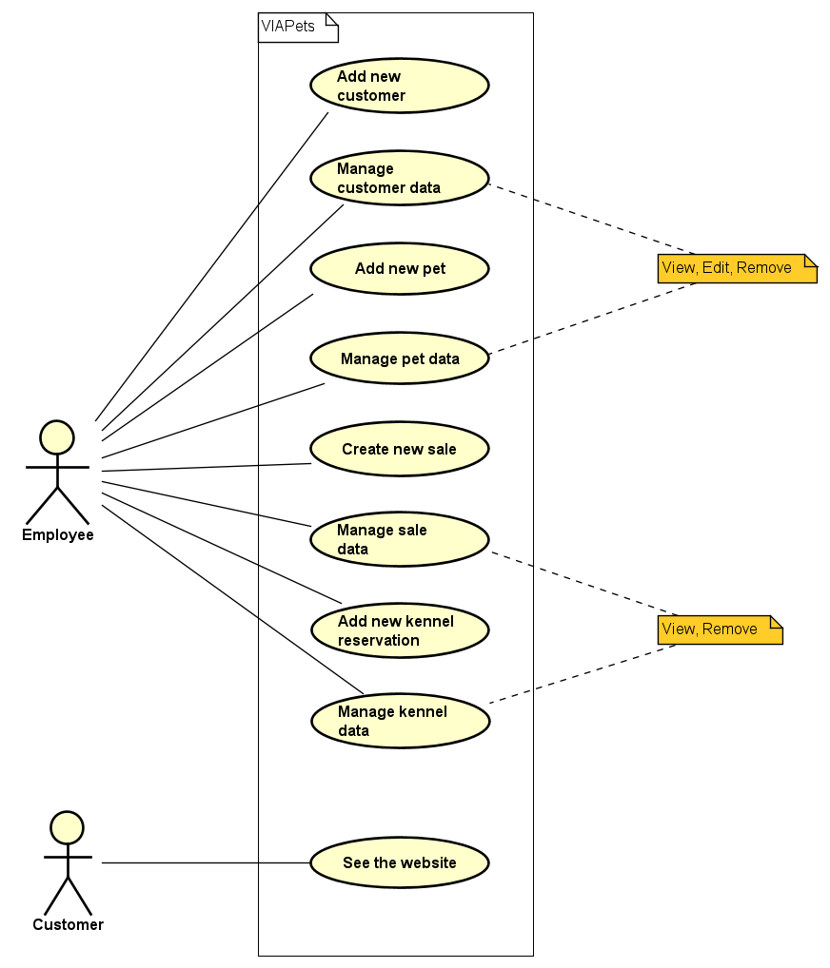

Use case descriptions
Use case | Add new customer
Summary | Create a new customer in system
Actor | Employee
Precondition | No precondition
Postcondition | A new customer has been added to the system (file).
Base sequence | - Enter values for:  - Customer first name  - Customer last name  - Phone number  - Email address  - Approve the entered data.  - System validates data. [ALT1, ALT2, ALT3]  - System adds a new customer with the given data to the list and file.  - System sends success message.  Use case ends.
Alternate sequence | [*ALT0] In step 1 the user can cancel the process. Use case ends.  [ALT1] If first name is not a String with a length of 3 or more characters, the system will display a message, saying the data is invalid and will go back to step 1.  [ALT2] If the phone number contains any letters, or it matches another phone number in the system, the system will display a message, saying the data is invalid. Goes back to step 1.  [ALT3] If the email address is not in the format user@host.domain, or the email address is already in the system, the system will display a message, saying the data is invalid. Goes back to step 1.
Note | A customer data has to be created with name, phone number and email address in order to buy a pet from the shop or put a pet in the kennel.  This use case covers requirement 2.

Use case | Manage customer data
Summary | View, edit or remove a customer’s data
Actor | Employee
Precondition | The data about the customer needs to be already stored in the system.
Postcondition | The system shows or updates an existing customer’s information, or an existing customer is removed from the list. Updates are both in system and file.
Base sequence | - The system shows a list of customers, each element with first name, last name and email address. [ALT1]  - Select the customer.  - The system shows customer data  - First name  - Last name  - Phone number  - Email  - If VIEW, then end the use case.  - If EDIT go to scenario A.  - If REMOVE go to scenario B.  SCENARIO A, EDIT A.1. Modify the value for at least one of the data shown in step 3. A.2. System validates the data [ALT2, ALT3, ALT4] A.3. System displays a success message.  SCENARIO B, REMOVE B.1. Verify removing. B.2. The system removes the customer’s data from the list and updates the system. B.3. System displays a success message.  Use case ends.
Alternate sequence | [*ALT0] The process can be canceled at any time. Ends the use case.  [ALT1] Search for the customer by entering first name or last name, the system displaying all the partial or full matches.  [ALT2] If first name is not a String with a length of 3 or more characters, the system will display a message, saying the data is invalid and will go back to step A.1.  [ALT3] If the phone number contains any letters, or it matches another phone number in the system, the system will display a message, saying the data is invalid. Go back to step A.1.  [ALT4] If the email address is not in the format user@host.domain, or the email address is already in the system, the system will display a message, saying the data is invalid. Go back to step A.1.
Note | This use case covers requirement 8, 9, 10.

Use case | Add new pet
Summary | Add a new pet
Actor | Employee
Precondition | No precondition
Postcondition | A new pet has been added to the system (file).
Base sequence | - Enter values for  - The type of animal {cat, dog, bird, fish, rodent, various}  - Price/Kennel  - Color  - Age  - Gender  - Name (optional)  - Additional comments  h1) If pet is “cat” or “dog”  Then also specific breed, name of the breeder  h2) If pet is “fish”  Then also species, water type, and if predator  h3) If pet is “bird”  Then also species, preferred food  h4) If pet is “rodent”  Then also species, and whether they bite  h5) If pet is “various”  Then also species  - Approve the entered data.  - System validates data. [ALT1, ALT2, ALT3, ALT4, ALT5, ALT6, ALT7]  - System adds new pet with given data to system.  Use case ends.
Alternate sequence | [*ALT0] In step 1, 2 the user can cancel the process, use case ends.  [ALT1] If the entered price is not a positive number or contains characters, the system displays an error message. Go back to step 1.  [ALT2] If the entered age is not a positive number or contains characters, the system displays an error message. Go back to step 1.  [ALT3] If the entered name contains digits, the system displays an error message. Go back to step 1.  [ALT4] If the price (if not in kennel), color, age and breed fields are not completed, the system displays an error message. Go back to step 1.  [ALT5] If the entered name of the pet contains digits, the system displays an error message. Go back to step 1.  [ALT6] If the entered for breed, breeder or species contains digits, the system displays an error message. Go back to step 1.  [ALT7] If the whole data of a new pet matches with another pet’s data, the system shows a message that a pet cannot be added twice. Go back to step 1.
Note | This use case covers requirement 1.

Use case | Manage pet data
Summary | View, edit or remove pet’s data
Actor | Employee
Precondition | The data about the pet needs to be already stored in the system.
Postcondition | The system shows or updates an existing pet's information, or an existing pet is removed from the list. Updates are both in system and file.
Base sequence | - The system displays the types.  - Select the type.  - The system shows a list of pets according to the selected type, each element with breed or species, color, gender, kennel status.  - Select the pet  - The system shows the pet data  - Type  - Price/ Kennel status  - Color  - Age  - Gender  - Name  - Additional comments  g1) If pet is “cat” or “dog”  Then also specific breed, name of the breeder  g2) If pet is “fish”  Then also species, water type, and if predator  g3) If pet is “bird”  Then also species, preferred food  g4) If pet is “rodent”  Then also species, and whether they bite  g5) If pet is “various”  Then also species  - If VIEW, then end use case.  - If EDIT, go to scenario A.  - If REMOVE, go to scenario B.  SCENARIO A EDIT A.1. Modify or add the value for at least one of the data shown in step 5. A.2. System validates the data [ALT1, ALT2, ALT3, ALT4, ALT5, ALT6, ALT7] A.3. System displays a successful message. A.4. System displays the updated values of the data as in step 5.  SCENARIO B REMOVE B.1. The system will ask if they are sure about the removal. [ALT8] B.2.Verify removing. B.3. The system removes the pet's data from the list and updates the system. B.4. System displays success message.  Use case ends.
Alternate sequence | [*ALT0] In step 1, 2 the user can cancel the process, use case ends.  [ALT1] If the entered price is not a positive number or contains characters, the system displays an error message. Go back to step A.1.  [ALT2] If the entered age is not a positive number or contains characters, the system displays an error message. Go back to step A.1.  [ALT3] If the entered name contains digits, the system displays an error message. Go back to step A.1.  [ALT4] If the price (if not in kennel), color, age and breed fields are not completed, the system displays an error message. Go back to step A.1.  [ALT5] If the entered name of the pet contains digits, the system displays an error message. Go back to step A.1.  [ALT6] If the entered for breed, breeder or species contains digits, the system displays an error message. Go back to step A.1.  [ALT7] If the whole data of a new pet matches with another pet’s data, the system shows a message that a pet cannot be added twice. Go back to step A.1.  [ALT8] The user has the choice to cancel. Go back to step 1.
Note | This use case covers requirements 5, 6, 7.

Use case | Create new sale
Summary | Creates a new sale
Actor | Employee
Precondition | There should be existing data about the pet that is being sold and the customer buying it.
Postcondition | A new sale has been added to the system’s network (file).
Base sequence | - Display a list for all pets.  - Select the pet.  - Display a list for all customers.  - Select the customer.  - The system fills in the current date and time.  - System fills in the initial price of the pet.  - Enter value if needed for the final price. [ALT1]  - Approve the entered data. [ALT2, ALT3]  - System validates data.  - System adds a new sale to the system.  - System sends successful message.
Alternate sequence | [*ALT0] The user can cancel the process at any time. Use case ends.  [ALT1] If the price is not a positive number or contains characters, the system displays an error that the value is invalid. Go back to step 7.  [ALT2] If pet is not selected, the system displays an error message that the pet is not selected.  [ALT3] If customer is not selected, the system displays an error message that the customer is not selected.
Note | This use case covers requirement 3.

Use case | Manage sale data
Summary | View and delete sale’s data
Actor | Employee
Precondition | Data about sales should be already stored in the system.
Postcondition | The system shows an existing sale’s information.
Base sequence | - The system shows a list of sales, each element with customer’s name, customer’s phone number, date of the sale and the price of the pet. [ALT1]  - Select the sale.  - The system shows the pet’s data:  - The type of animal {cat, dog, bird, fish, rodent, various}  - Name (if it’s stored)  - Age  - Color  - Price  - Gender  - Additional comments  h1) If pet is “cat” or “dog”  Then also specific breed, name of the breeder  h2) If pet is “fish”  Then also species, water type, and if predator  h3) If pet is “bird”  Then also species, preferred food  h4) If pet is “rodent”  Then also species, and whether they bite  h5) If pet is “various”  Then also species  - If VIEW, end the use case.  - If REMOVE, go to scenario A.  SCENARIO A REMOVE A.1 Select delete. A.2 The system displays a warning message. [ALT2] A.3. The system removes the sale data from the list and updates the system. A.4. The system displays a successful message.  Use case ends.
Alternate sequence | [*ALT0] The use case can be cancelled in step 1. Use case ends.  [ALT1] Search for the sale by entering customer’s phone number. System displays full matches.  [ALT2] The user has the choice to cancel the action. Go back to step 1.
Note | This use case covers requirement 14.

Use case | Add new kennel reservation
Summary | Adds a new kennel reservation
Actor | Employee
Precondition | The maximal number of pets in the kennel is 10
Postcondition | A new kennel reservation has been added to the system. (file)
Base sequence | - Displays a list of all the pets  - Select the pet  - Displays a list of all the customers  - Select the customer  - Enter value for [ALT1, ALT2, ALT3]  - Check-in date and time  - Check-out date and time  - The system fills out a suggested value for price per day. [ALT4, ALT5]  - Approve the entered data.  - System validates data. [ALT6]  - System adds a new kennel reservation to the system, list and file.  - System sends successful message.
Alternate sequence | [*ALT0] The user can cancel the process at any time. Use case ends.  [ALT1] If the check-in date and time is before the current date and time or after the check-out date and time, the system displays an error message. Go back to step 1.  [ALT2] If the check-out date and time is before the current date and time or is before the check-in date and time, the displays an error message. Go back to step 1.  [ALT3] Check if there are available spaces during the time given, if not system displays that there is no space available. Go back to step 1.  [ALT4] The user has the option to change the price per day of the reservation.  [ALT5] If the price is not a positive number the system displays an error that the value is invalid. Go back to step 3.  [ALT6] If the values of the pet, the customer and the check-in and check-out date match another kennel reservation the system displays an error message. Go back to step 1.
Note | This use case covers requirement 4, 17.

Use case | Manage kennel data
Summary | View or remove kennel reservation
Actor | Employee
Precondition
Postcondition | The system shows an existing kennel reservation, or an existing kennel reservation is removed from the list. Updates are both in system and file.
Base sequence | - The system shows a list of all kennel reservations, each element with the customer, check-in date, check-out date and final price. [ALT1]  - Select the kennel reservation  - The system displays the pet data  - If VIEW, end use case.  - If REMOVE, go to scenario A.  SCENARIO A REMOVE A.1. Verify removing. A.2. The system removes the reservations data from the list and updates the system. A.3. The system displays a successful message.  Use case ends.
Alternate sequence | [*ALT0] The user can cancel the process at step 1,2. Use case ends.  [ALT1] Search for the kennel reservation by entering the customer phone number, displaying full matches.
Note | A reservation can be removed only if the pet is not currently in the kennel.  This Use Case covers requirements 11, 12, 13.

Use case | See the website
Summary | Displaying a website
Actor | Customer
Precondition
Postcondition
Base sequence | - Customer goes to viapets.domain  - The customer can access the required information  - Use case ends.
Alternate sequence | [*ALT0] The website is constantly updated by the system, adding, editing or removing existing pet shop listings or kennel reservations.
Note | This use case covers requirements 15, 16.

Use Case | Covered requirements
Add new customer | 2
Manage customer data | 8, 9, 10
Add new pet | 1
Manage pet data | 5, 6, 7
Add new sale | 3
Manage sale data | 14
Add new kennel reservation | 4, 17
Manage kennel data | 11, 12, 13
See the website | 15, 16

Use case ”Add new customer” activity diagram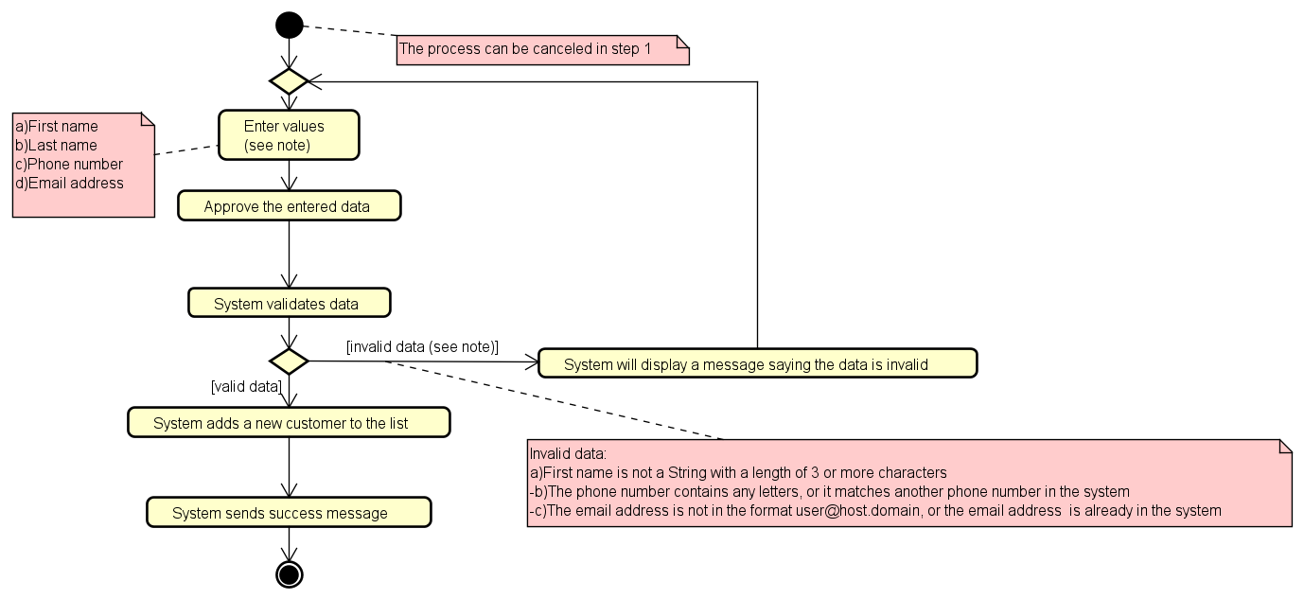
Use case” Manage customer’s data” activity diagram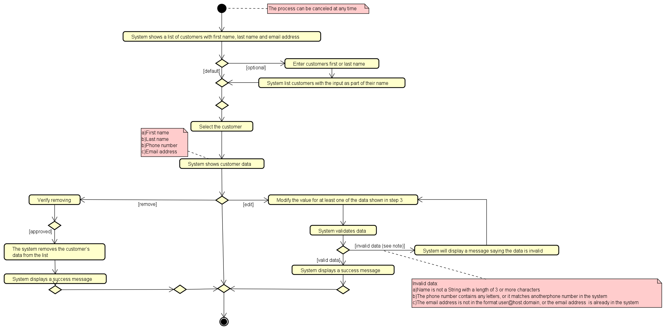

Use case “Add new pet” activity diagram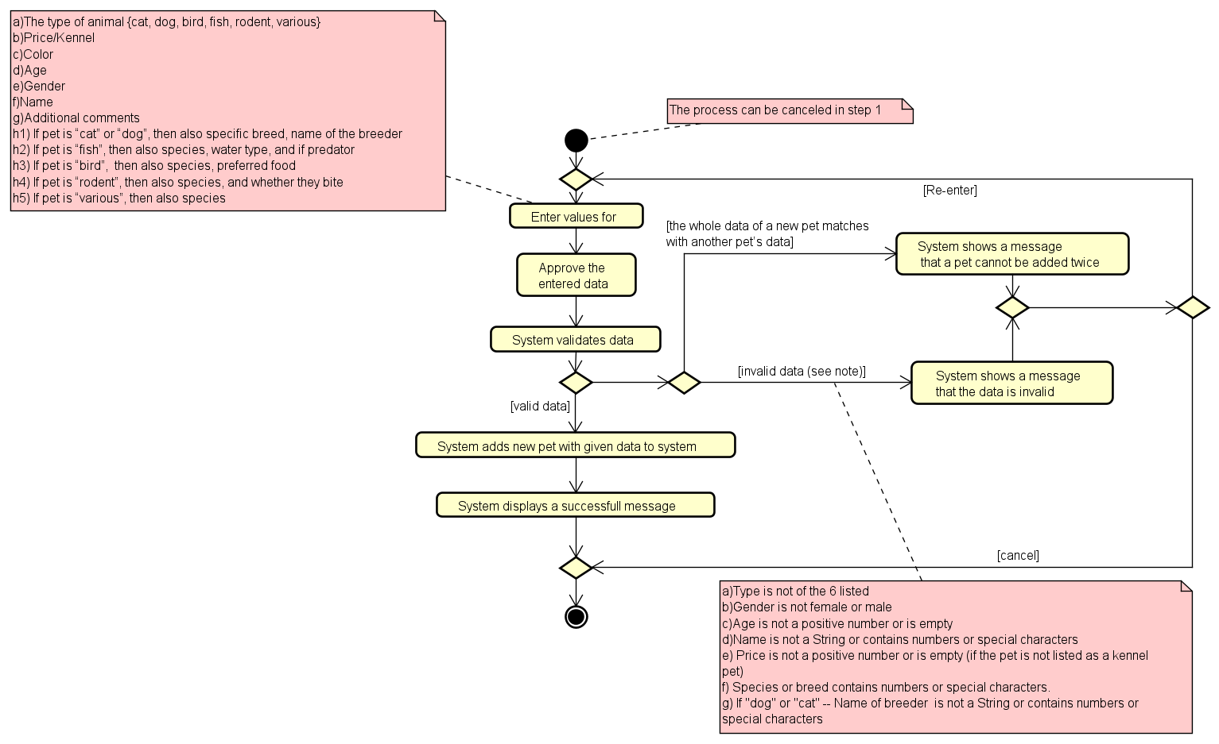

Use case ”Manage pet data” activity diagram
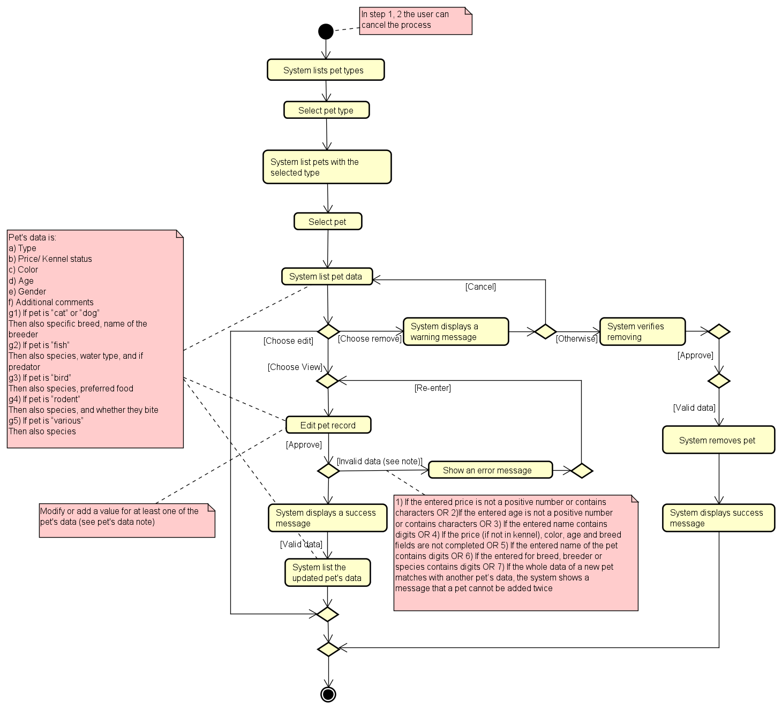
Use case ”Create new sale” activity diagram

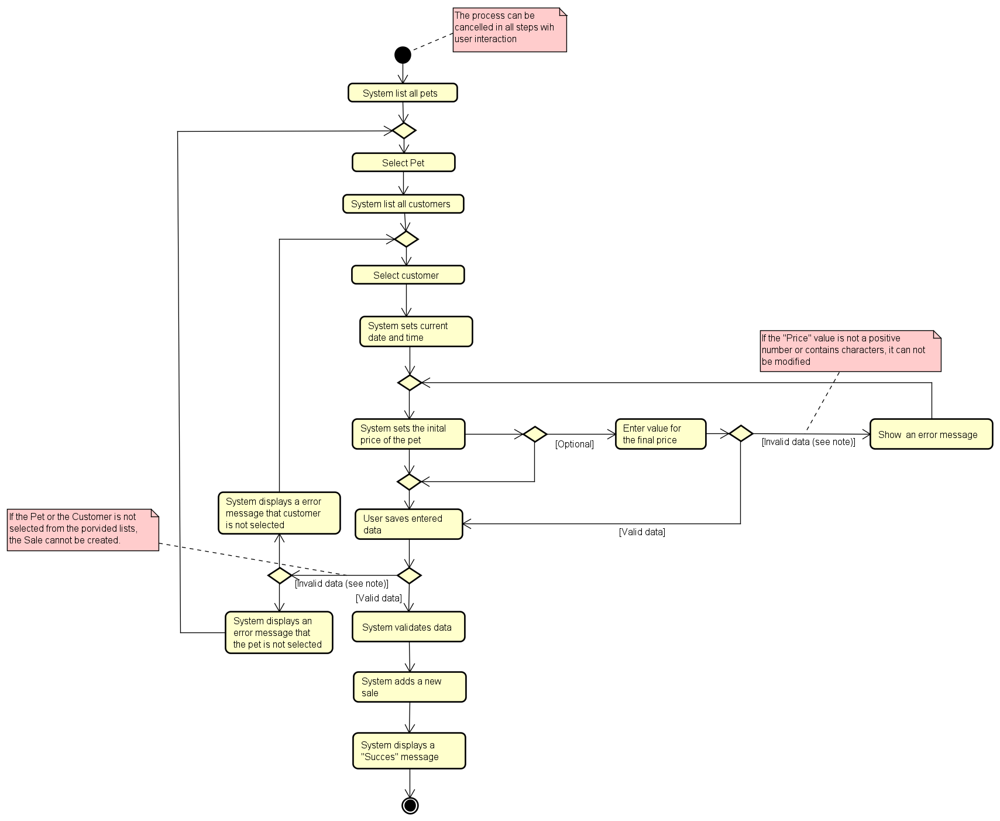
Use case ”Manage Sale” activity diagram
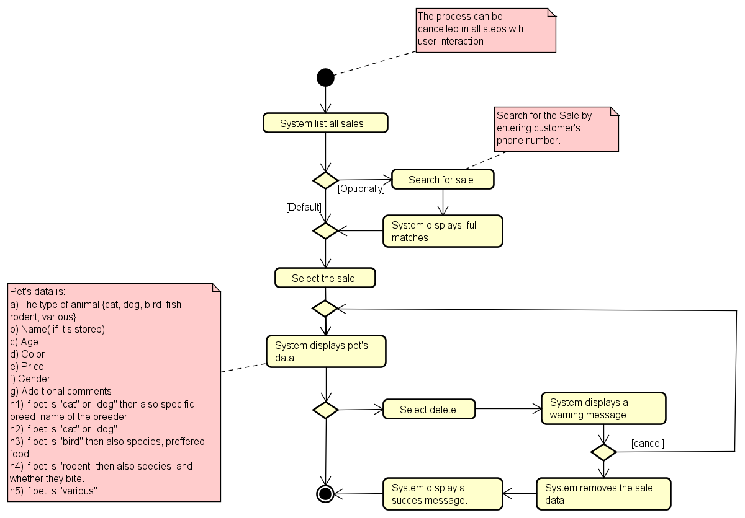
Use case “Add new kennel reservation” activity diagram
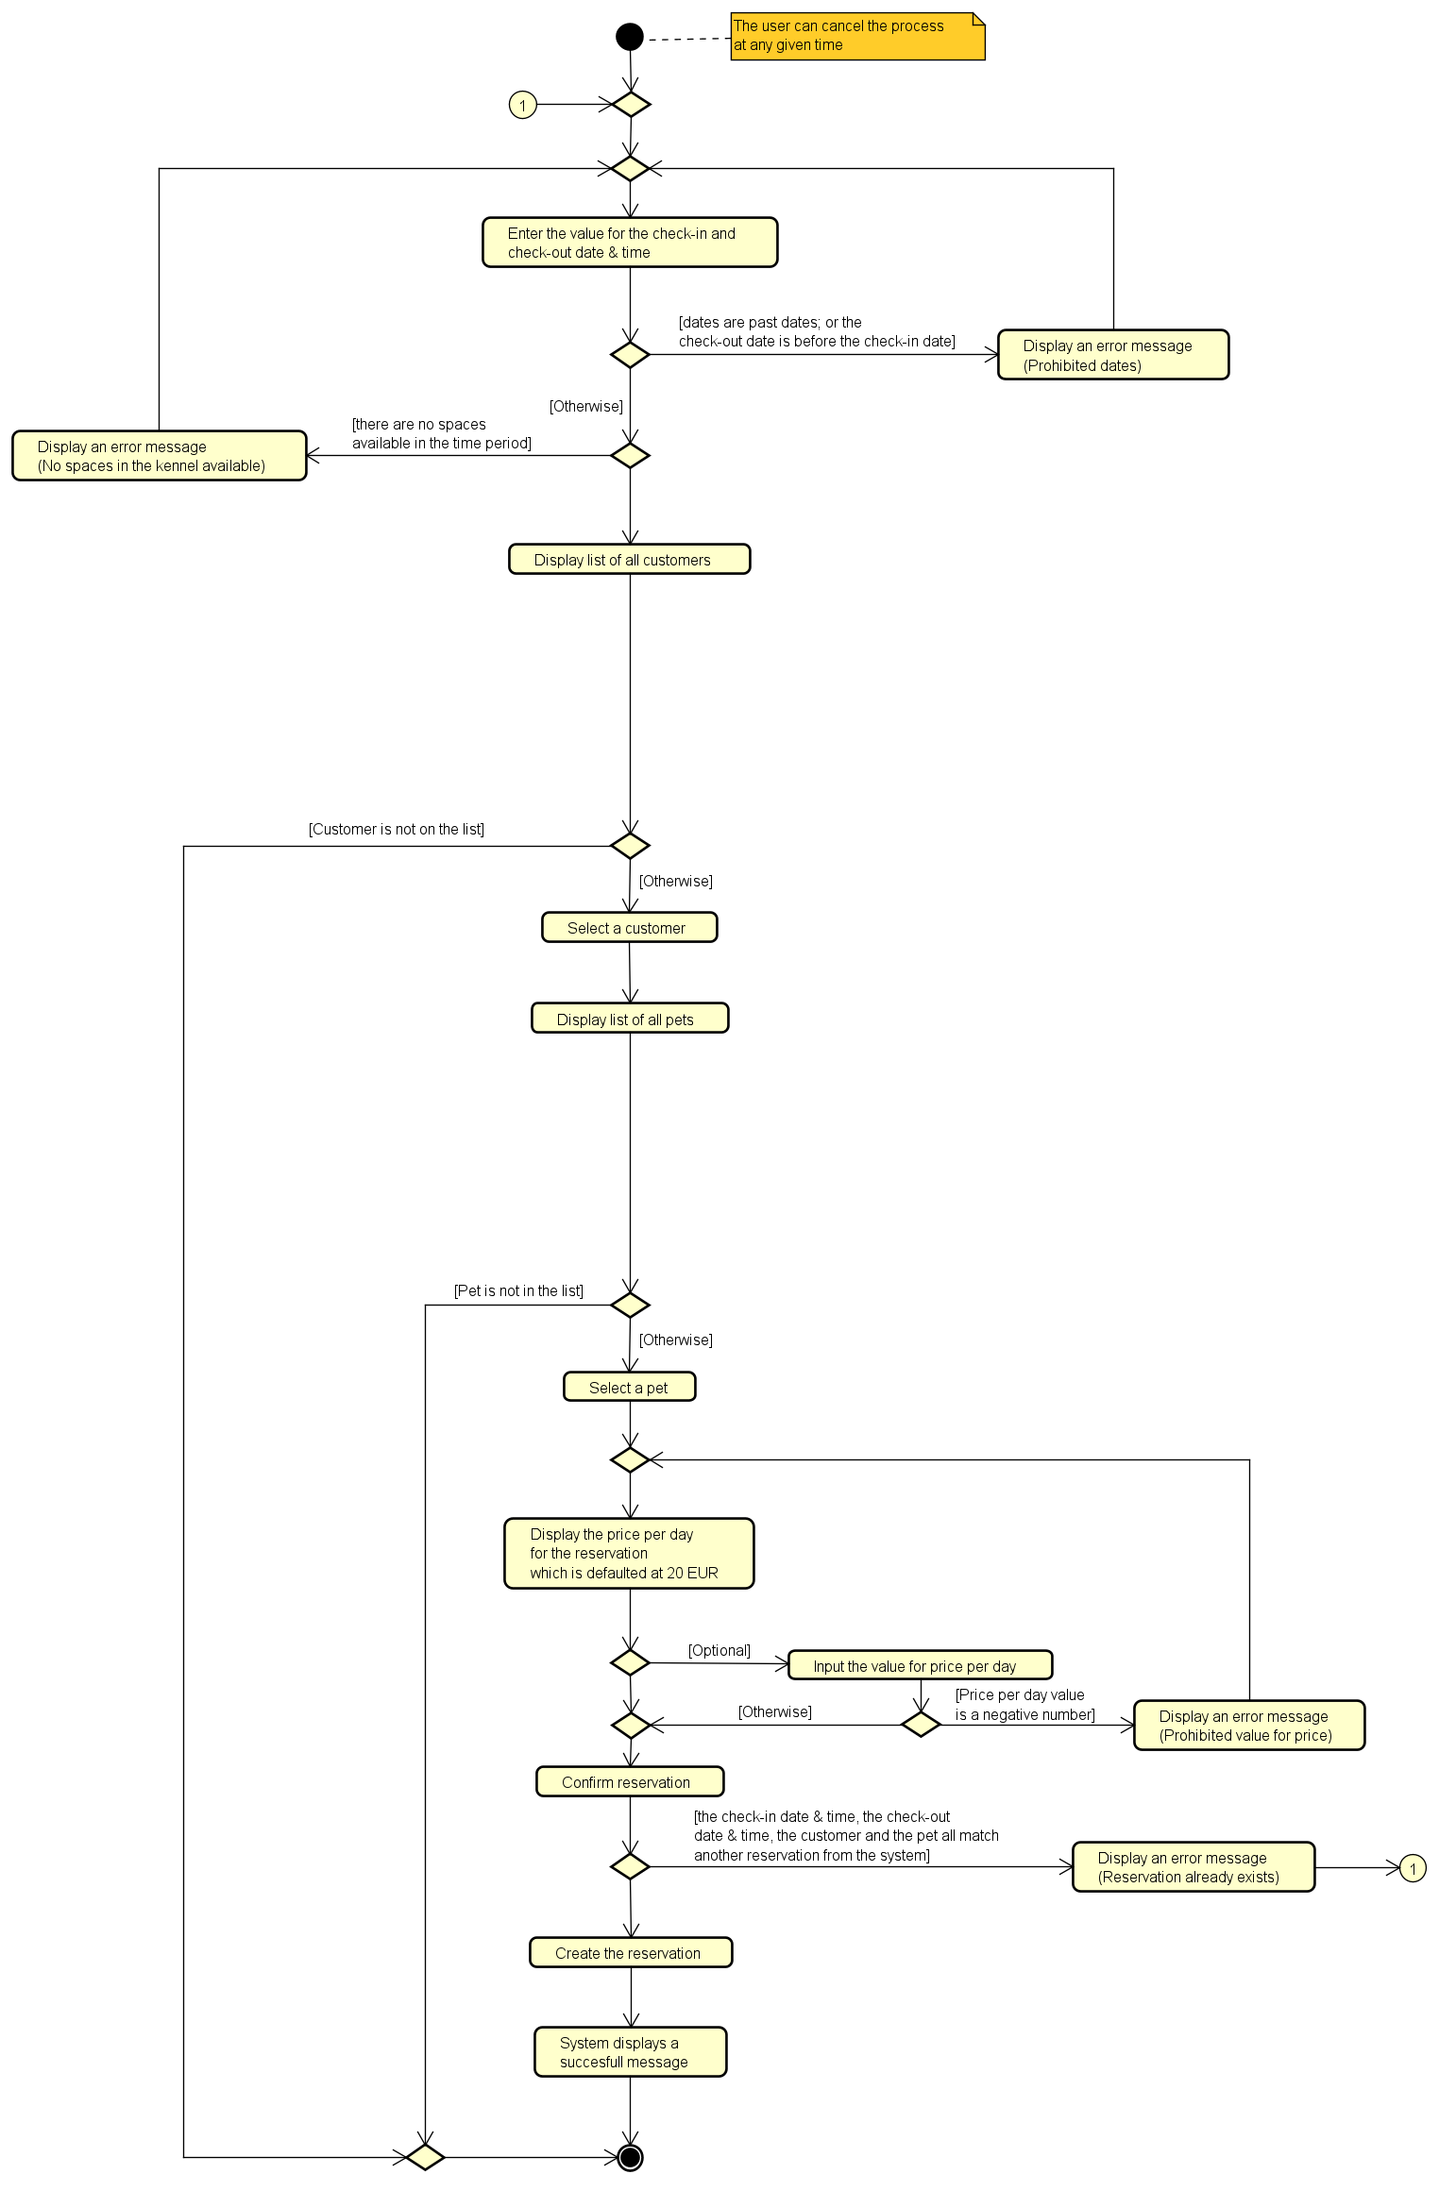

Use case “Manage kennel data” activity diagram
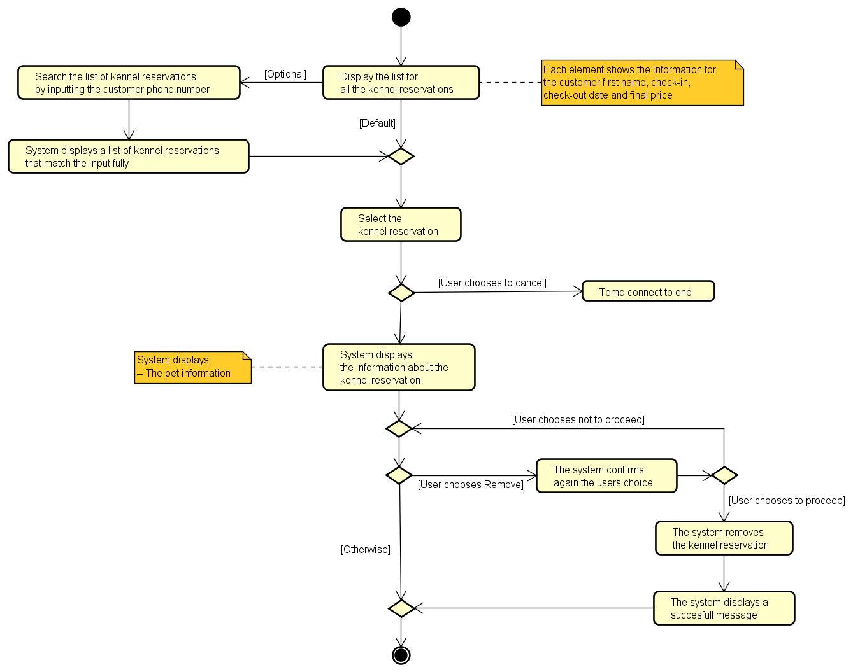

Use case “See the website” activity diagram
